housing 1
  - Residential property prices and housing characteristics
Ruoxi Rachel Liu | Ongoing project | September 2026 revision
An exploratory analysis of 1,460 Ames housing sales. Quality, living area, and neighborhood are associated with sale price; these comparisons do not establish causal effects.

Correlation Heatmap
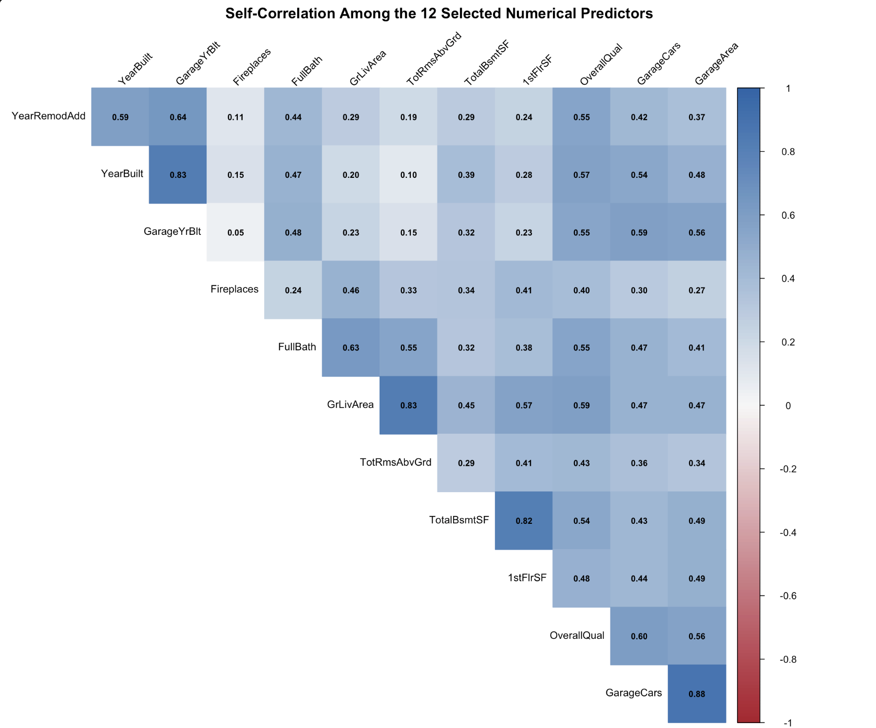
This heatmap shows how the selected housing characteristics are related to each other. Darker blue indicates a stronger positive correlation. For example, garage area and garage capacity have a correlation of about 0.88, which makes sense because larger garages usually fit more cars. This means these two variables provide some overlapping information. When building a regression model, we should check whether including both makes it difficult to separate their individual relationships with sale price.

Living Area and Sale Price
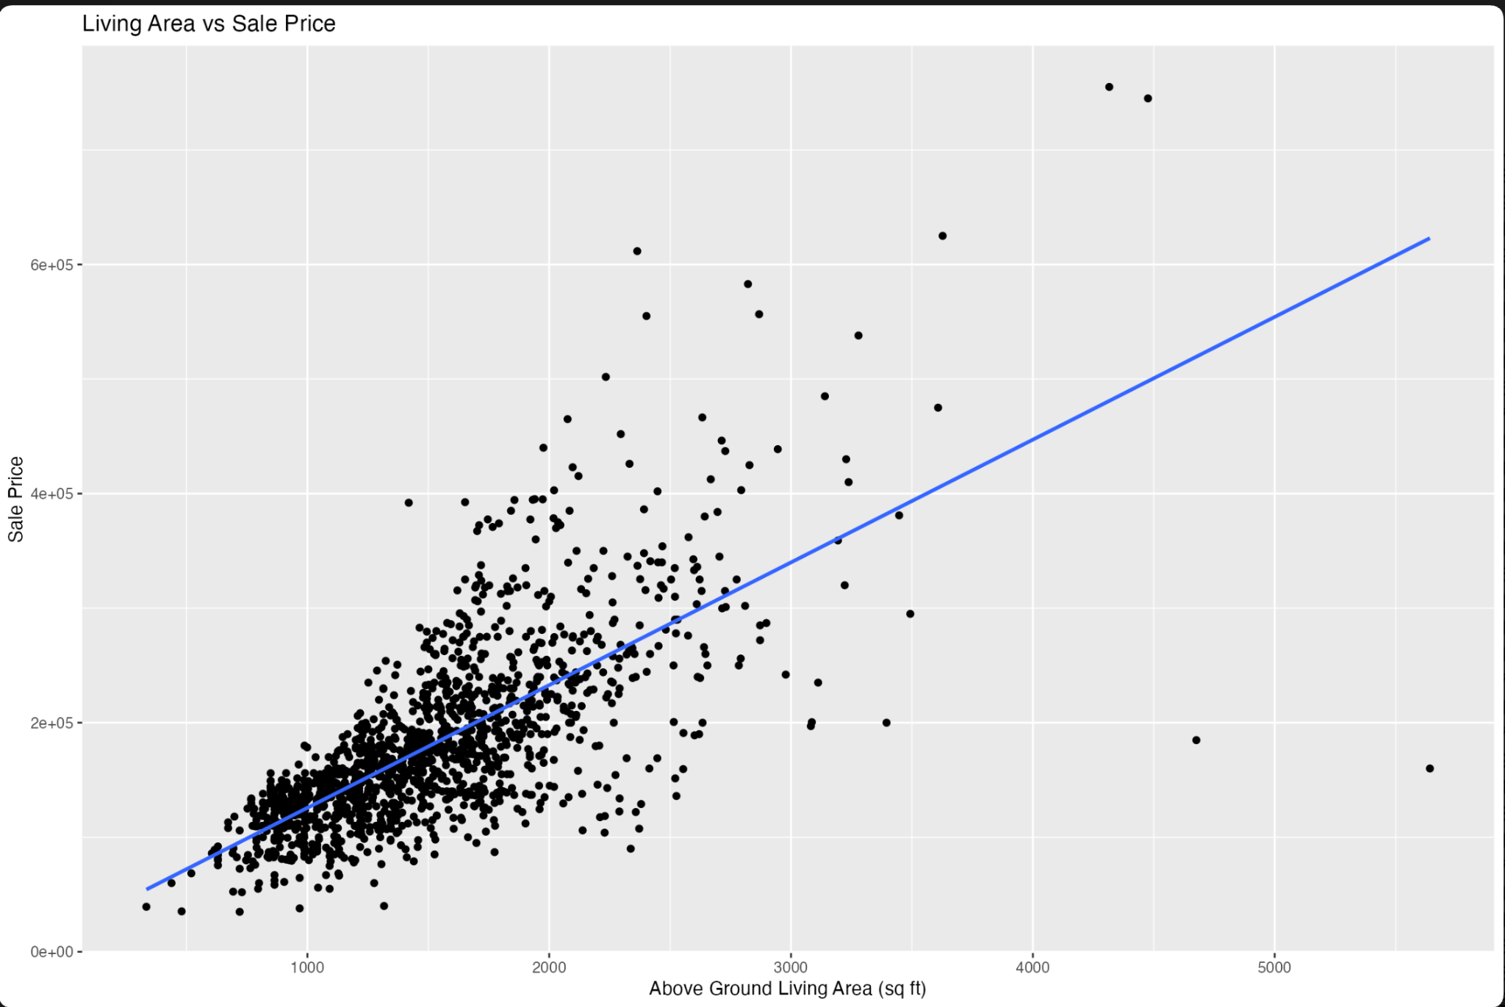
This scatterplot shows the relationship between above-ground living area and sale price. Each point represents one home, and the upward-sloping line shows that larger homes generally sell for higher prices. However, the points do not fall exactly on the line, so homes with similar living areas can have different prices. We can also see a few unusually large homes with relatively low sale prices. These observations deserve further investigation, but they are not necessarily data errors.

Overall Quality and Sale Price
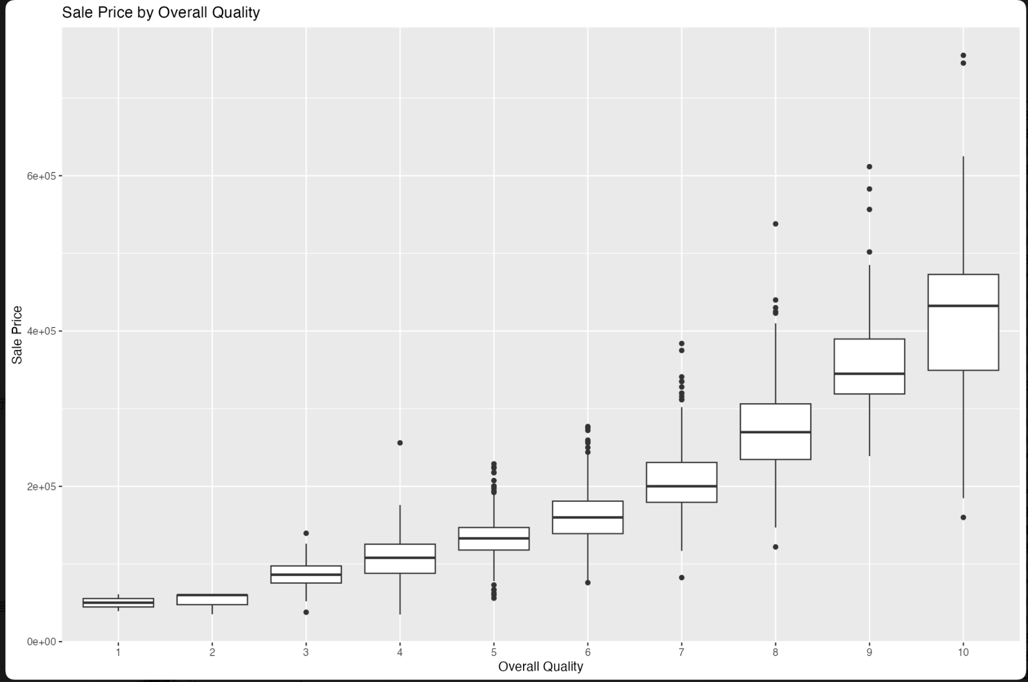
This boxplot compares sale prices across overall quality ratings. The line inside each box represents the median sale price for that group. There is a clear upward pattern: as quality ratings increase, median prices also increase. For example, homes rated nine have a much higher median price than homes rated five. However, prices still vary within each quality group, suggesting that characteristics such as living area and neighborhood are also related to price.

Neighborhood and Sale Price
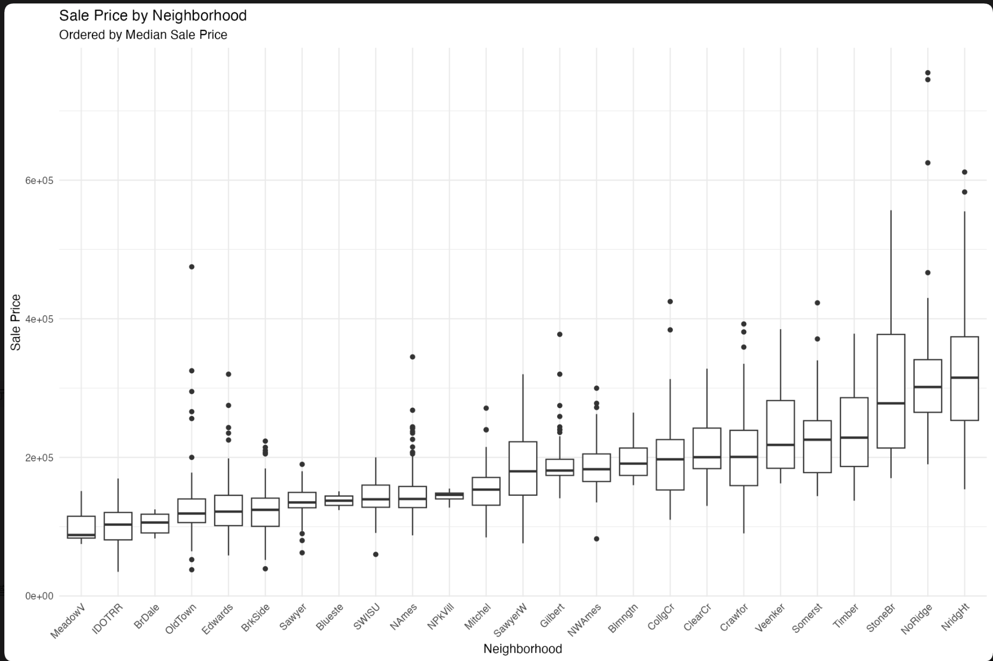
This graph compares sale prices across neighborhoods, ordered from the lowest to the highest median price. The differences between neighborhoods are substantial, with some groups having much higher typical prices than others. The boxes also show that prices vary within each neighborhood. This suggests that neighborhood is useful when studying housing prices. However, we cannot attribute all the price differences to location alone, because homes in different neighborhoods may also differ in size, quality, and age.

Year Built and Sale Price
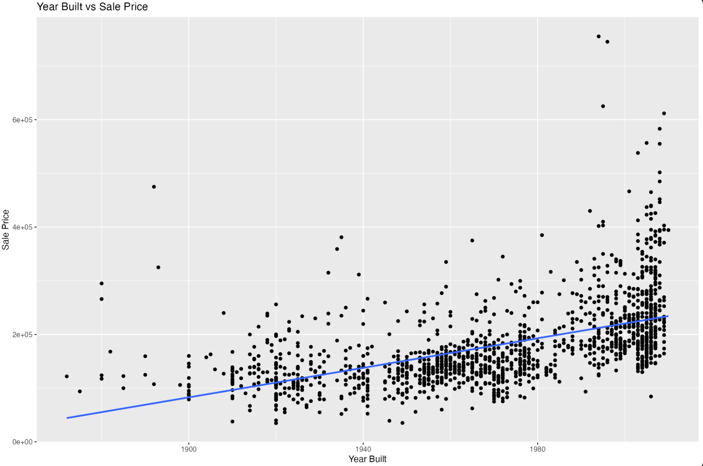
This scatterplot shows the relationship between the year a home was built and its sale price. The upward-sloping line suggests that newer homes generally sell for higher prices. However, there is considerable variation, especially among homes built in more recent years. This means construction year alone cannot explain why one home is more expensive than another. Also, this graph compares homes built in different years; it does not show how housing prices changed over time.

Garage Area and Sale Price
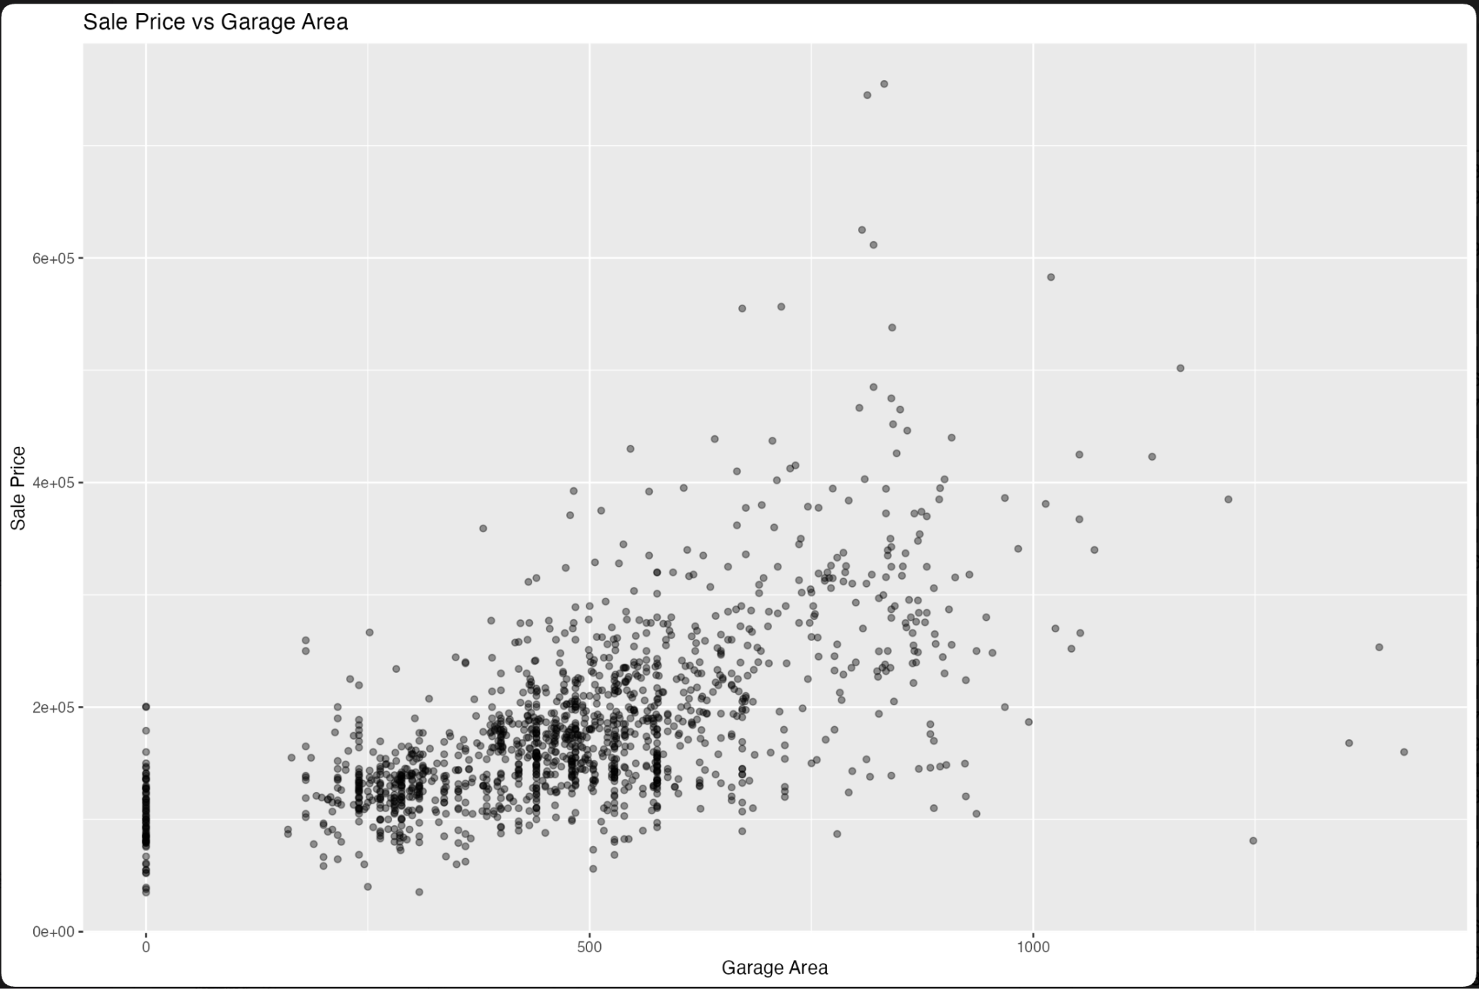
This scatterplot compares garage area with sale price. Overall, we can see a positive relationship, meaning homes with larger garages generally sell for more. However, homes with similar garage areas can have very different prices, and some homes with very large garages have relatively low prices. Larger garages may also be found in larger or higher-quality homes. Therefore, this graph does not prove that increasing garage area by itself would cause a higher sale price.

Garage Capacity and Sale Price
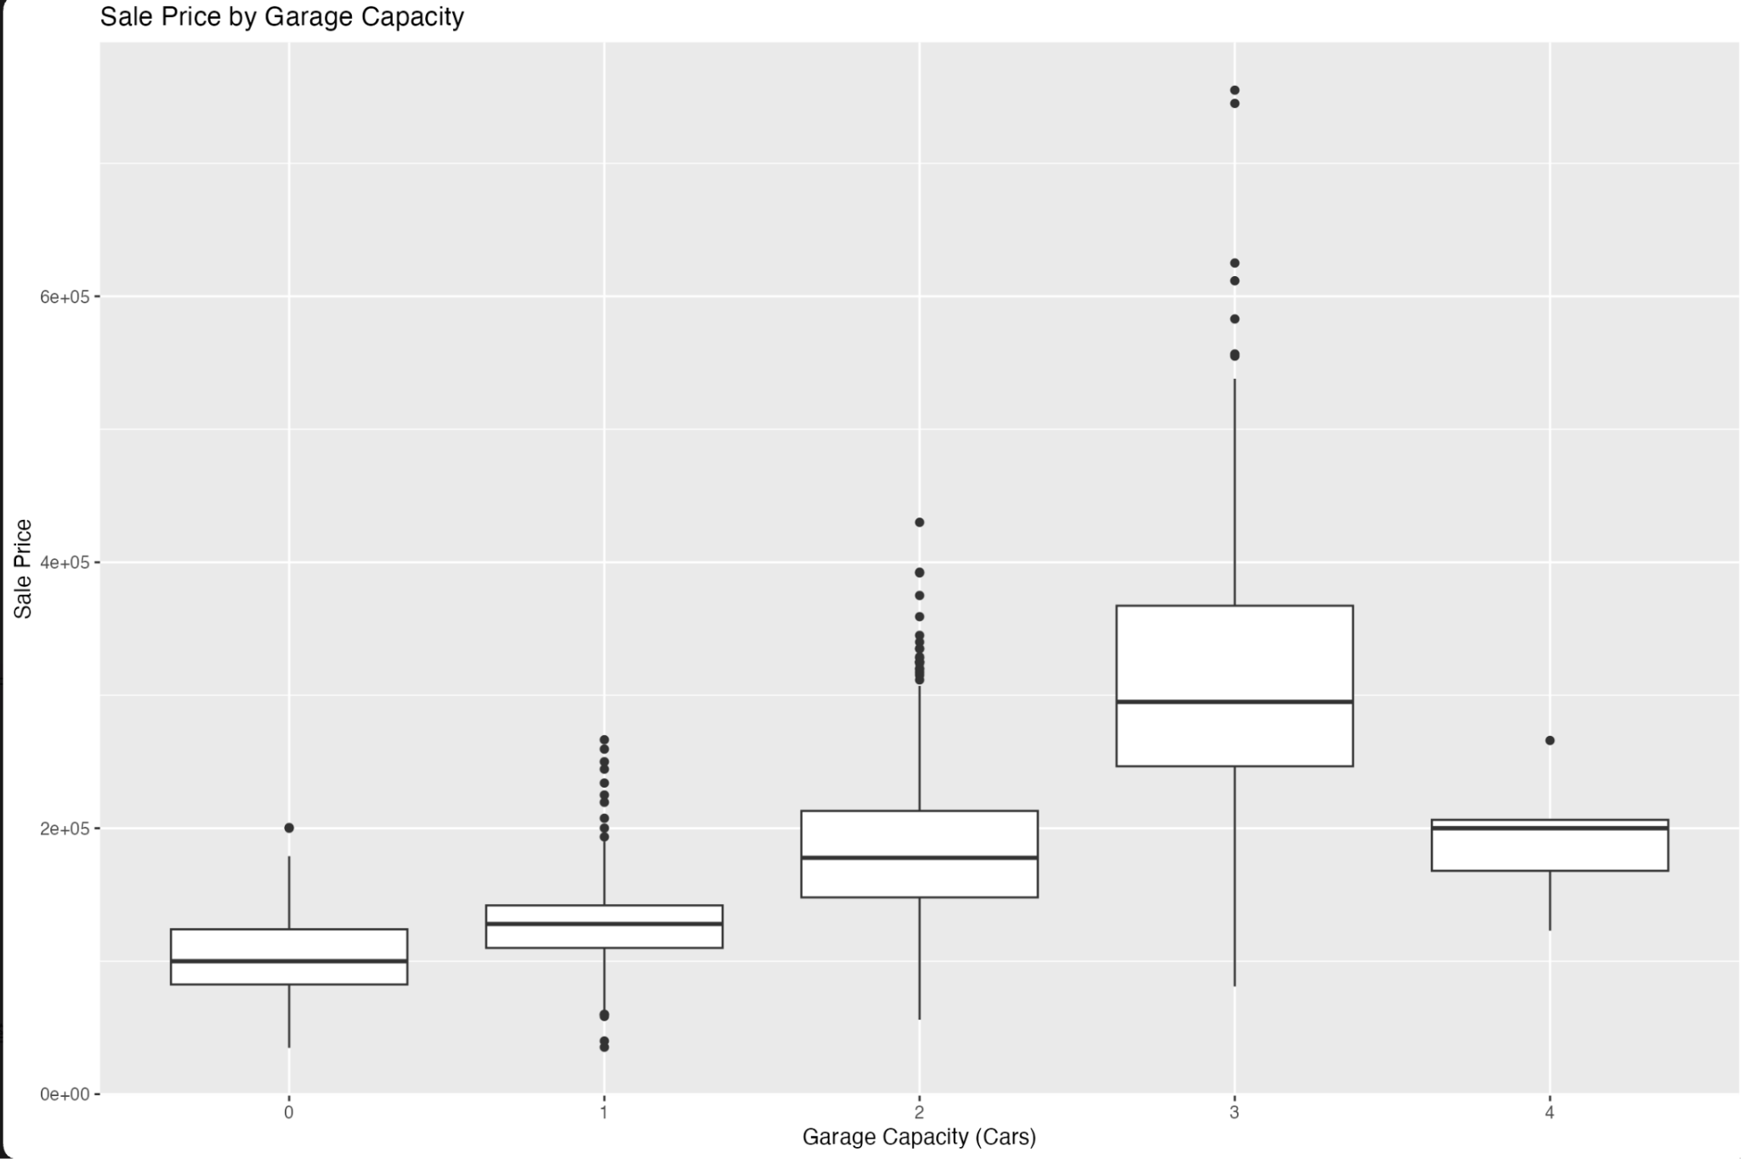
This boxplot compares sale prices based on how many cars a garage can hold. Median prices increase from homes with no garage to homes with three-car garages. The three-car group has the highest median price, while the four-car group has a lower median. However, there are only five homes in the four-car group, compared with 181 in the three-car group. We should therefore be cautious about this comparison and avoid concluding that four-car garages reduce home values.

Overall Condition and Sale Price
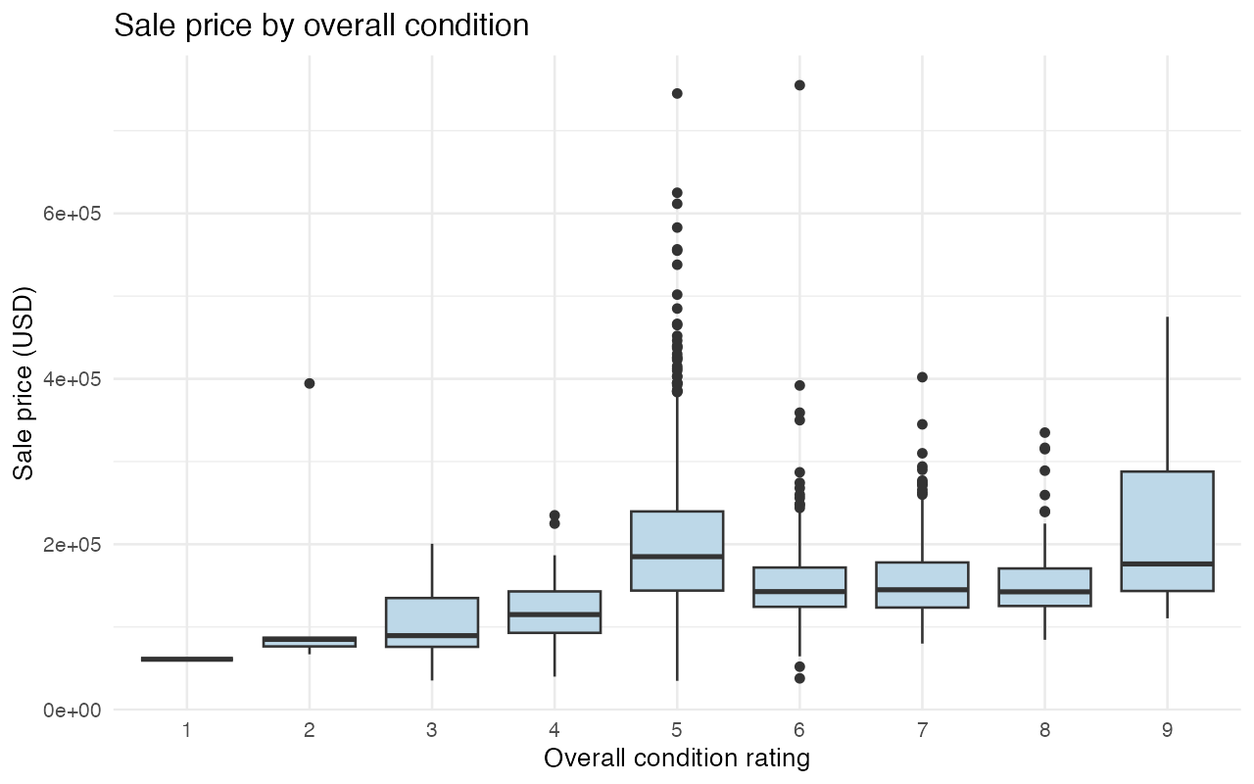
This boxplot compares sale prices across overall condition ratings. Unlike overall quality, condition does not show a clear and consistent upward relationship with price. The group with a condition rating of five includes many expensive homes and also contains more than half of the observations. It is important to distinguish condition from quality: a home can be well maintained without having high-end materials or finishes. Overall, condition alone provides a limited picture of sale price, so we should consider it alongside other housing characteristics.

